Name 1:李璇 SID 1: 12010137 Name 2: 张林燊 SID 2: 12010424

实验报告#1 (Lab#1)

**1.4**

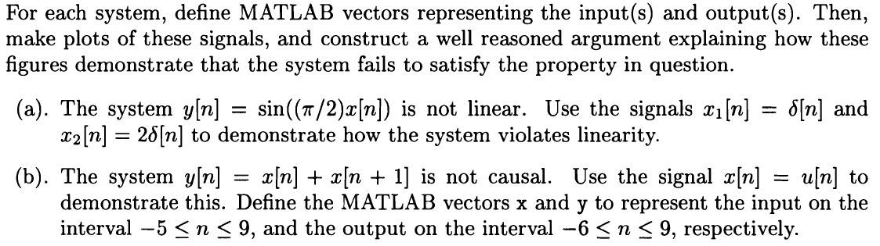

**Solution:**

(a)

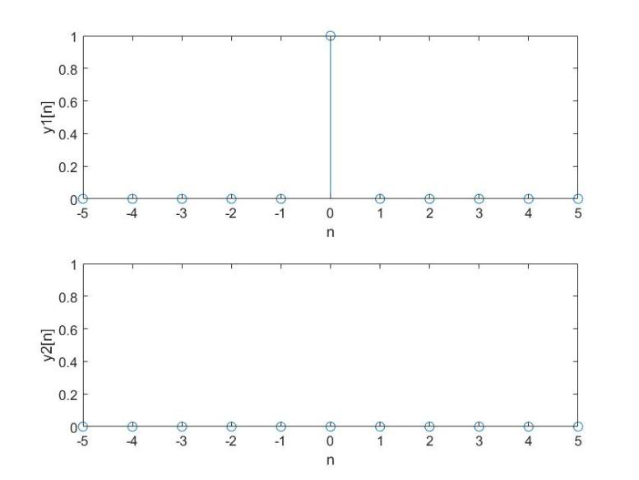

, but , so the system is not linear.

**MATLAB Code:**

n = -5:5;

x1 = zeros(1,11);

x1(6) = 1;

x2 = 2*x1;

y1 = sin(pi/2.*x1);

y2 = sin(pi/2.*x2);

subplot(2,1,1);

stem(n,y1);

axis([-5 5 0 1]);

xlabel('n');

ylabel('y1[n]');

subplot(2,1,2);

stem(n,y2);

axis([-5 5 0 1]);

xlabel('n');

ylabel('y2[n]');

(b)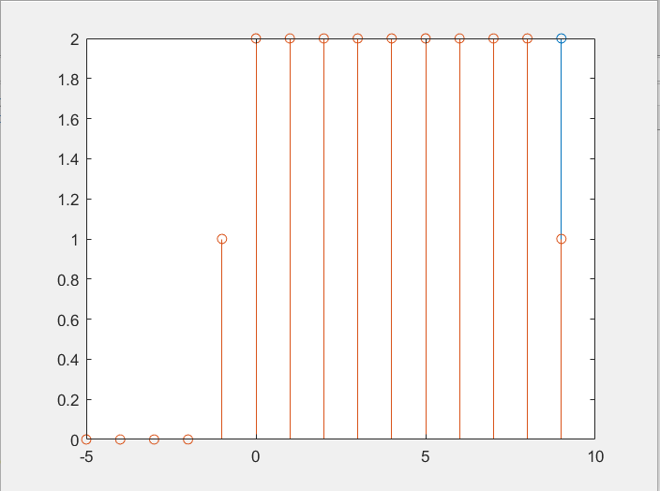

Because the images that are not in the range of independent variables are different when n=10 is defined or not, there is no causality.

**MATLAB Code:**

n=-5:9;

x1=[zeros(1,5),ones(1,10)];

x2=[zeros(1,4),ones(1,11)];

y=x1+x2;

stem (n,y);

hold on;

k=-5:9;

x11=[zeros(1,5),ones(1,10)];

x12=[zeros(1,4),ones(1,10),0];

y2=x11+x12;

stem(k,y2);

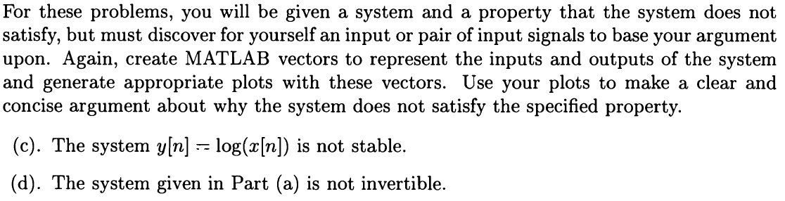

**Solution:**

(c)

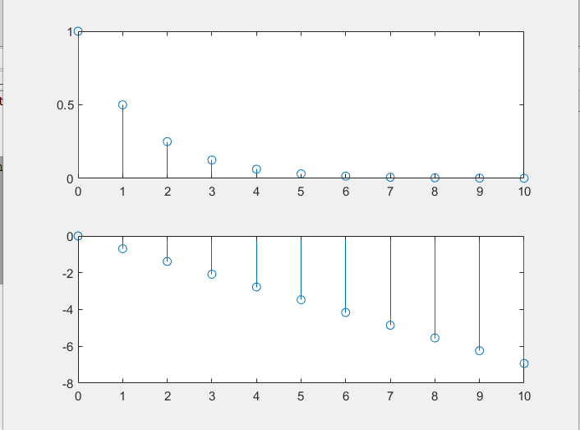

When x = (0.5) n, y=n*log(0.5) can be obtained. It can be seen from the figure that y decreases infinitely when x has a limit.

**MATLAB Code:**

>> n=0:10;

x1=(0.5).^n;

x2=log(x1);

subplot(2,1,1);

stem(n,x1);

subplot(2,1,2);

stem(n,x2);

(d)

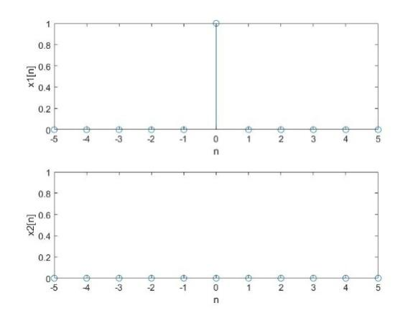

The inverted function is x[n]=(2/Π)arcsin(x[n]). But when y2[n] is acting as the input, the output is obviously not x2[n]. So the system is not invertible.

**MATLAB Code:**

n=-5:5;

x1=zeros(1,11);

x1(6)=1;

x2=zeros(1,11);

y1=(2/pi)*asin(x1);

y2=(2/pi)*asin(x2);

subplot(2,1,1);

stem(n,y1);

axis([-5 5 0 1]);

xlabel('n');

ylabel('x1[n]');

subplot(2,1,2);

stem(n,y2);

axis([-5 5 0 1]);

xlabel('n');

ylabel('x2[n]');

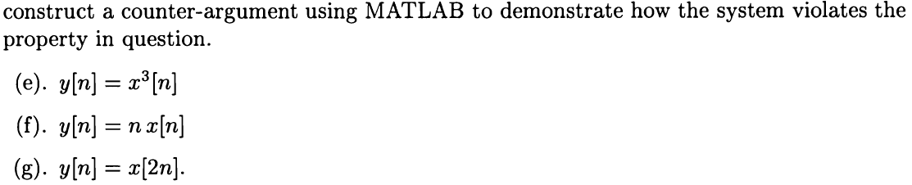

**Solution:**

(e)

(1) The system is not linear. Take x1=δ[n] and x2=2δ[n], x2=x1 while y2≠y1.

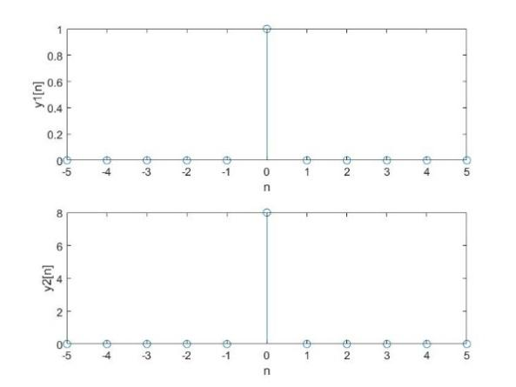

**MATLAB Code:**

n=-5:5;

x1=zeros(1,11);

x1(6)=1;

x2=2*x1;

y1=x1.*x1.*x1;

y2=x2.*x2.*x2;

subplot(2,1,1);

stem(n,y1);

axis([-5 5 0 1]);

xlabel('n');

ylabel('y1[n]');

subplot(2,1,2);

stem(n,y2);

axis([-5 5 0 8]);

xlabel('n');

ylabel('y2[n]');

(2) The system is time-invariant.

(3) The system is causal.

(4) The system is stable.

(5) The system is invertible.

(f)

(1) The system is linear.

(2) The system is not time-invariant. When x1[n]= δ[n] and x2[n]=x1[n+1], y2[n] ≠y1[n+1].

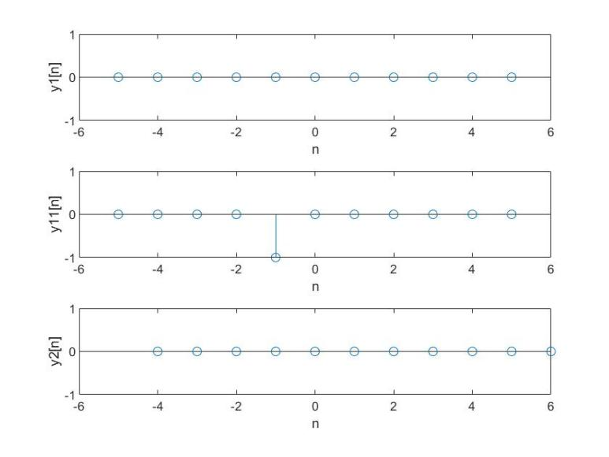

**MATLAB Code:**

n1=-5:5;

x1=zeros(1,11);

x1(6)=1;

n2=-4:6;

x2=zeros(1,11);

x2(5)=1;

y1=n1.*x1;

y11=n1.*x2;

y2=n2.*x2;

subplot(3,1,1);

stem(n1,y1);

axis([-6 6 -1 1]);

xlabel('n');

ylabel('y1[n]');

subplot(3,1,2);

stem(n1,y11);

axis([-6 6 -1 1]);

xlabel('n');

ylabel('y11[n]');

subplot(3,1,3);

stem(n2,y2);

axis([-6 6 -1 1]);

xlabel('n');

ylabel('y2[n]');

(3) The system is causal.

(4) The system is not stable. When x[n]=1, x[n] is bounded while y[n]=n which is not bounded.

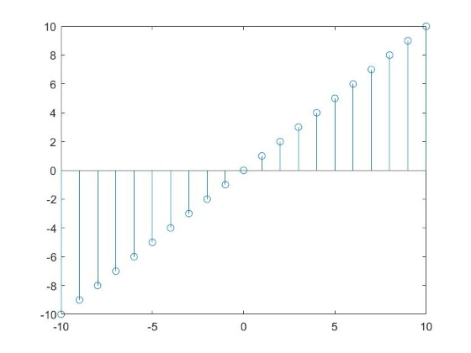

**MATLAB Code:**

n=-10:10;

x=ones(1,21);

y=n.*x;

stem(n,y);

axis([-10 10 -10 10]);

(5) The system is invertible.

(g)

(1) The system is linear.

(2) The system is not time-invariant. When x2=x1[n-2], y2[n] ≠y1[n-2].

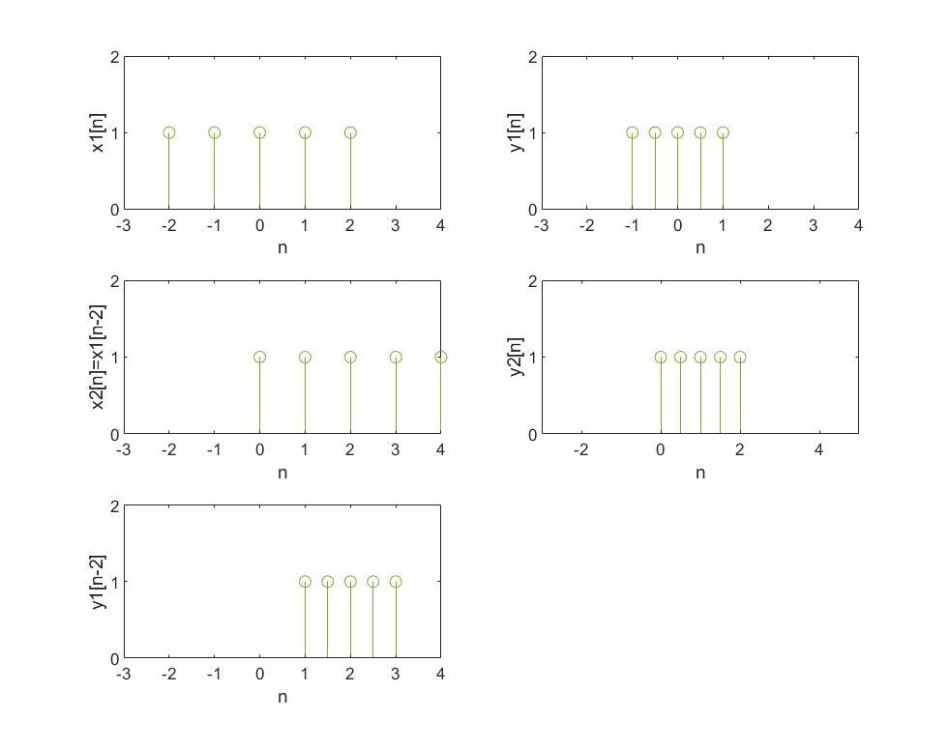

**MATLAB Code:**

n1=-2:2;

x1=ones(5);

y1=ones(5);

n2=(1/2).*n1;

subplot(3,2,1);

stem(n1,x1);

axis([-3 4 0 2]);

xlabel('n');

ylabel('x1[n]');

subplot(3,2,2);

stem(n2,y1);

axis([-3 4 0 2]);

xlabel('n');

ylabel('y1[n]');

n3=0:4;

x2=ones(5);

y2=ones(5);

n4=(1/2).*n3;

subplot(3,2,3);

stem(n3,x2);

axis([-3 4 0 2]);

xlabel('n');

ylabel('x2[n]=x1[n-2]');

subplot(3,2,4);

stem(n4,y2);

axis([-3 5 0 2]);

xlabel('n');

ylabel('y2[n]');

n5=n2+2;

subplot(3,2,5);

stem(n5,y1);

axis([-3 4 0 2]);

xlabel('n');

ylabel('y1[n-2]');

(3) The system is not causal. When n>0, 2n>n, so the system is not causal.

(4) The system is stable.

(5) The system is invertible.

**1.5**

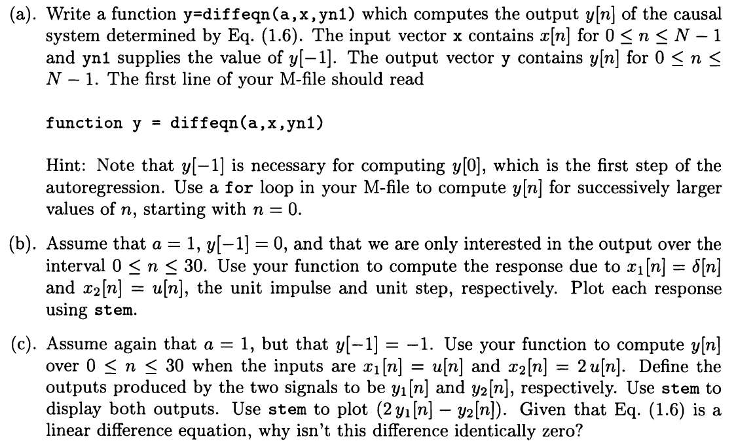

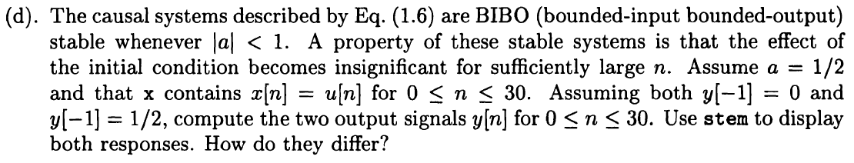

**Solution:**

**MATLAB Code:**

function y=diffeqn(a,x,yn1)

y=zeros(1,size(x,2));

yn1=yn1+x(1);

for n=1:size(x,2)-1

if n==1

y(n)=a*yn1+x(n+1);

else

y(n)=a*y(n-1)+x(n+1);

end

end

a=1;

%因为索引都是正整数，所以以第一个数字作为x（0）

x=[ones(1,31)];

yn1=0;

y = diffeqn(a,x,yn1);

k=0:30;

stem(k,y);

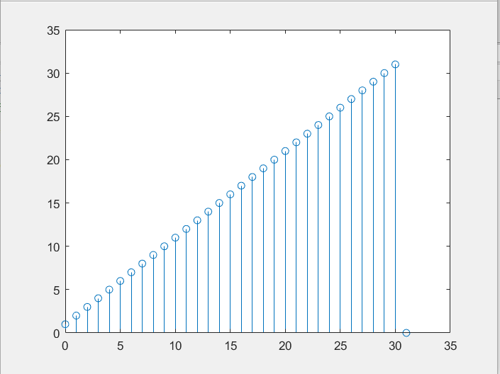

（c）

a=1;

x=[ones(1,31)];

yn1=-1;

y1=diffeqn(a,x,yn1);

x2=2*x;

y2=diffeqn(a,x2,yn1);

k=0:31;

stem(k,y1);

hold on;

stem(k,y2);

hold on;

stem (k,2*y1-y2);

legend('y1[n]','y2[n]','2y1[n]-y2[n]')

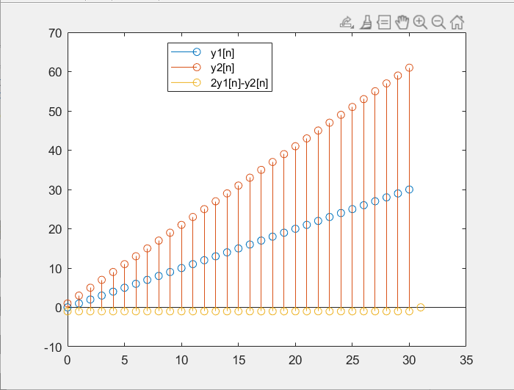

（d）

a=0.5;

x=[ones(1,31)];

yn1=0;

y1=diffeqn(a,x,yn1);

yn2=0.5;

y2=diffeqn(a,x,yn2);

k=0:31;

stem(k,y1);

hold on;

stem(k,y2);

legend('y1[n]','y2[n]')

